Comparing the Performance of Dinamica EGO
Thanks to its innovative framework, which includes 64-bit native version, parallel processing using a hybrid method named task + work stealing and smart management of data flow, Dinamica EGO can far surpass performance of most common GIS.

Least Cost Pathway Calculation

Dataset and Models
 | The test data and the models used in the comparison can be downloaded at here.
The example consists of two sets of maps extracted from IDRISI tutorial: land use map (worcwest), source map (newplant) and destination map (powerline). The first one at 15 meter resolution composed of 960 columns x 960 rows and the second at 5 meter resolution composed of 2880 columns x 2880 rows (respectively, folders resource and resource5). Dinamica EGO models are in folders ego_15m and ego_5m; we made available models with 2, 3 passes and optimum solution. In general, only two to three passes are needed to approximate to an optimum solution. Respective models implemented on MacroModeler are located in Idrisi_15m and Idrisi_5m 1), and folder arcgis contains the ModelBuilder model2).

Results
Figures below show the pathways calculated with three passes and another with optimum solution using Dinamica EGO as well as the pathways output from MacroModeler and ModelBuilder.
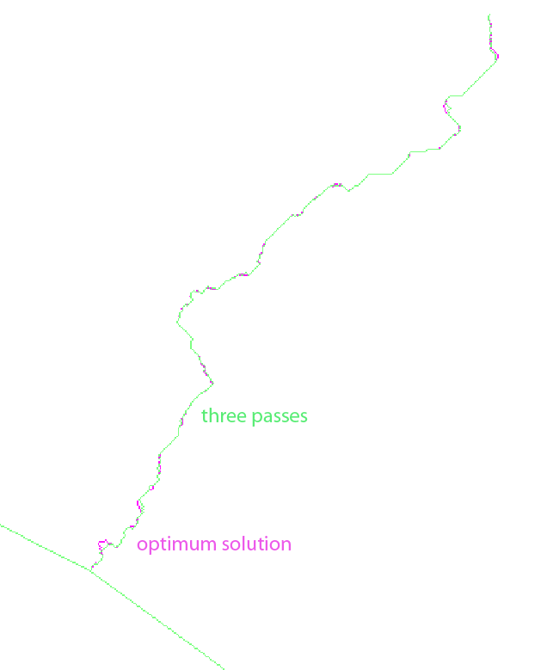Results produced by Dinamica EGO
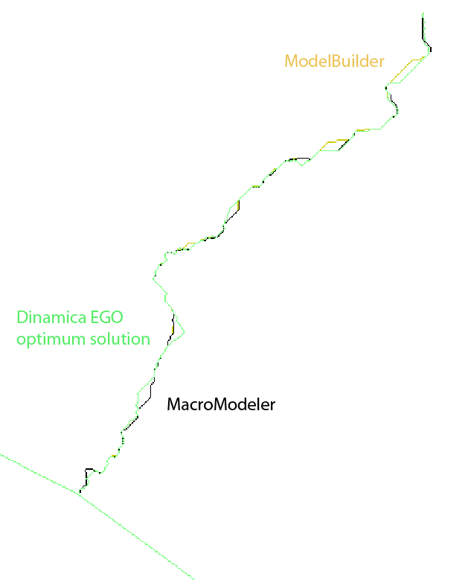Comparison of results produced by all softwares

Final Thoughts
Check out yourself this comparison downloading the test data and running the models on your computer. Any doubts please contact dinamica@csr.ufmg.br.

1) you might need to specify the working directory before running the Idrisi model
2) Go to Arctool; you will need to add the model as a toolbox and then click on it to open and run the ModelBuilder model

