Landscape
In this model the landscape is represented by an image in which the pixel values are the amount of resources.
The landscape map is an input designed according to the study context.
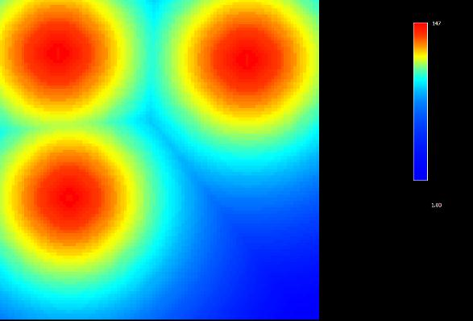
In this map, for example, the resources are heterogeneously distributed and there are 3 places with higher resources concentration.
The maximum capacity of resources in the cell and the Recovery speed of the landscape are attributes of the landscape. At each time step the landscape recovers itself according to Recovery speed of the landscape considering its maximum capacity which is the initial cell value of the landscape map.
Attribute value
Constants | Values
Recovery speed of the landscape | 0,01
Back to Model Dynamics

