Map group
Map groups can be created from a series of loaded maps (currently in the stack). Groups are not only useful to aggregate information but they also allow users to execute a single Calculate Expression for a number of maps.

How to create a map group
You start by clicking the toolbar button “Create map group”, the following dialog will prompt:
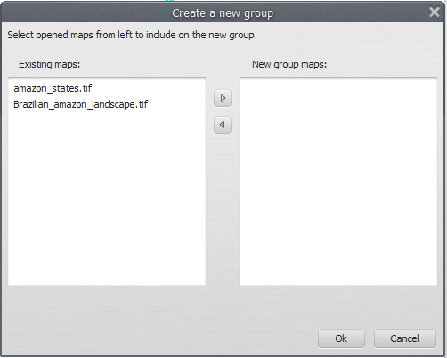
You then will be able to select maps from the left column (loaded in the stack) and shift them to the right columns, to construct a new group.
The new group will look like a normal loaded map, except it will show maps in the group with their respective indices for the Calculate Expression


