Welcome to Dinamica EGO 5
Congratulations! You have successfully installed Dinamica EGO 5!

What is New
Dinamica EGO 5 brings several groundbreaking improvements in several areas:
Execution
- The parallel execution system was rebuilt from scratch making this the fastest Dinamica EGO ever! Now, the parallel execution uses a fixed number of execution threads (called workers) with task stealing to provide load balancing and increase the flexibility of how parallel tasks can be designed. In theory, all model components can run in parallel:
  - Independent functors run in parallel;
  - Independent loop steps run in parallel;
  - Different pieces of a map are loaded in parallel.
  - Individual settings in the Execution tab of the Options dialog controls how parallel execution works.
- Thousands of internal optimizations.
- Now images are manipulated in parallel even when they are too big to fit in memory.
- Additional of new options to control how memory allocation for maps works.
- [EXPERIMENTAL] Certain functors can have their execution accelerated using GPUs (called accelerators). The use of Nvidia and AMD GPU models released after 2016 is advised.
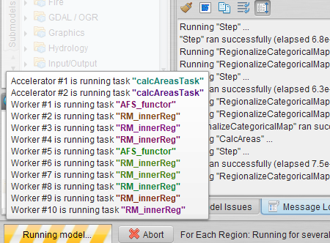
Internationalization
- Now it is possible to provided file paths, and comments and alias for functors in almost any language. The graphical interface itself is still available only in English, though.
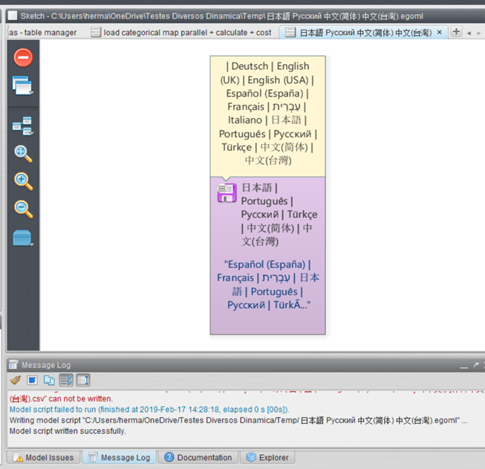
Integration
- Improved integration with R: It is now possible to install packages even if R is being provided by the Enhancement Plugin. Just replace the typical import statement 'library (NAME)' with 'dinamicaPackage(“NAME”)' when importing packages from your scripts. By doing so, packages will be automatically downloaded and installed, if necessary. An option in the Options dialog control
- Integration with Python: Python can now be used to create functors, via Calculate Python Expression as part of the models. It is now possible to install packages by using 'dinamica.package(“NAME”)' when importing packages. Similarly how it works for R, Python packages will be automatically downloaded and installed from the PIP repository, if necessary. Packages can also be installed from custom locations. And unlike R, the Python interpreter is deployed with Dinamica EGO, so it is possible to use Python to create functors out of the box.
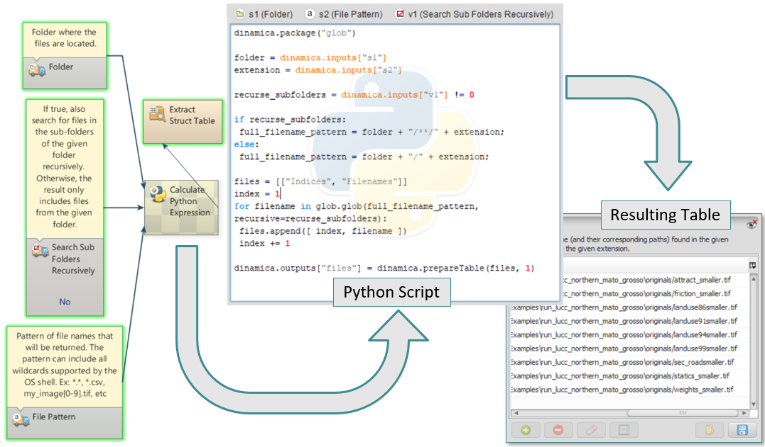
Portable
- Windows version can be used without having to be installed (portable version). However, the full installer is still recommended for easier deployment and for a better overall experience.
Submodels
- Submodels and functors can now be nested with multiple levels in the Functor Library tree.
- Submodels can place inputs in custom tabs (other than the default or advanced tabs) in the Functor Editor dialog.
- Submodels are loaded “lazily” when the application starts. As the result, Dinamica tends to initialize very quickly, even when dozen of submodels are installed.
Miscelaneas
- More uniform settings (variables and registry). Most settings can be overridden using an environment variable for convenience.
- Virtualization Off is no longer available.
- New command line tool.
- Thousands of bug fixes.
Platform
- Dinamica EGO 5 is 64-bit only application.
- Compiled using the latest compilers.
- Available for Windows, Linux and Mac.

Videos
We are still updating the documentation, including the guidebook, to cover features available on the new version of Dinamica EGO. Meanwhile, check some short videos showing how to use some of the features of the new release.

Discussion Group
Now, take some time to join our discussion group. The Dinamica EGO Discussion Group is a forum, powered by Google Groups, where you can ask questions about Dinamica EGO in English, Spanish or Portuguese. The group also helps you to remain informed about Dinamica EGO updates and news.

Wiki
You can find valuable informations about how to explore the potential of Dinamica EGO by consulting the Dinamica EGO wiki.

Troubleshooting
If you are having problems running Dinamica EGO, please visit our troubleshooting FAQ. The FAQ is a comprehensive list of solutions and workarounds for several common issues.

Additional Plugins
It is also possible to download and install the Enhancement Plugin for Dinamica EGO. This plugin can be used to speed up the execution of some Dinamica EGO operators under certain circumstances and it also allows R scripts to be used as part of Dinamica EGO models.

