Dinamica EGO 5

Overview
EGO stands for Environment for Geoprocessing Objects. Dinamica EGO consists of a sophisticated platform for environmental modeling with outstanding possibilities for the design from the very simple static spatial model to very complex dynamic ones. Its main features includes:
- Model design as diagrams using data-flow language on a friendly graphical interface,
- Nested iterations,
- Multi-transitions,
- Dynamic feedbacks,
- Multi-region,
- Multi-scale approach,
- Decision processes for bifurcating and joining execution pipelines,
- A series of complex spatial algorithms for the analysis and simulation of space-time phenomena.
- Sub-models,
- Model wizards,
- Genetic Algorithm for model calibration
- High performance, including 64-bit native version, full parallelism using multiprocessor computing architecture, smart handling of large raster datasets
- BioDinamica plug-in for analyses of biodiversity, biogeography and macroecology
The software environment, written in C++ and Java, holds a series of algorithms called functors. Each functor performs an operation. We have implemented the most common spatial analysis algorithms available in commercial GIS (Geographic Information System), plus a series of algorithms especially designed for spatial simulations, including transition functions and calibration and validation methods.
Dinamica EGO functors are sequenced in a graph form to establish a visual data flow. With the help of its graphical interface, one can create models by simply dragging and connecting functors via their ports, each of which represents a connector to a data element, such as a map, a table, a matrix, a mathematical expression, or a constant. Thus, models can be designed as a diagram, whose execution follows a data flow chain. This friendly interface allows for creative design of spatial models that are saved in XML or EGO script format.
In sum, Dinamica-EGO favors simplicity, flexibility and performance, optimizing speed and computer resources, such as memory and parallel processing.
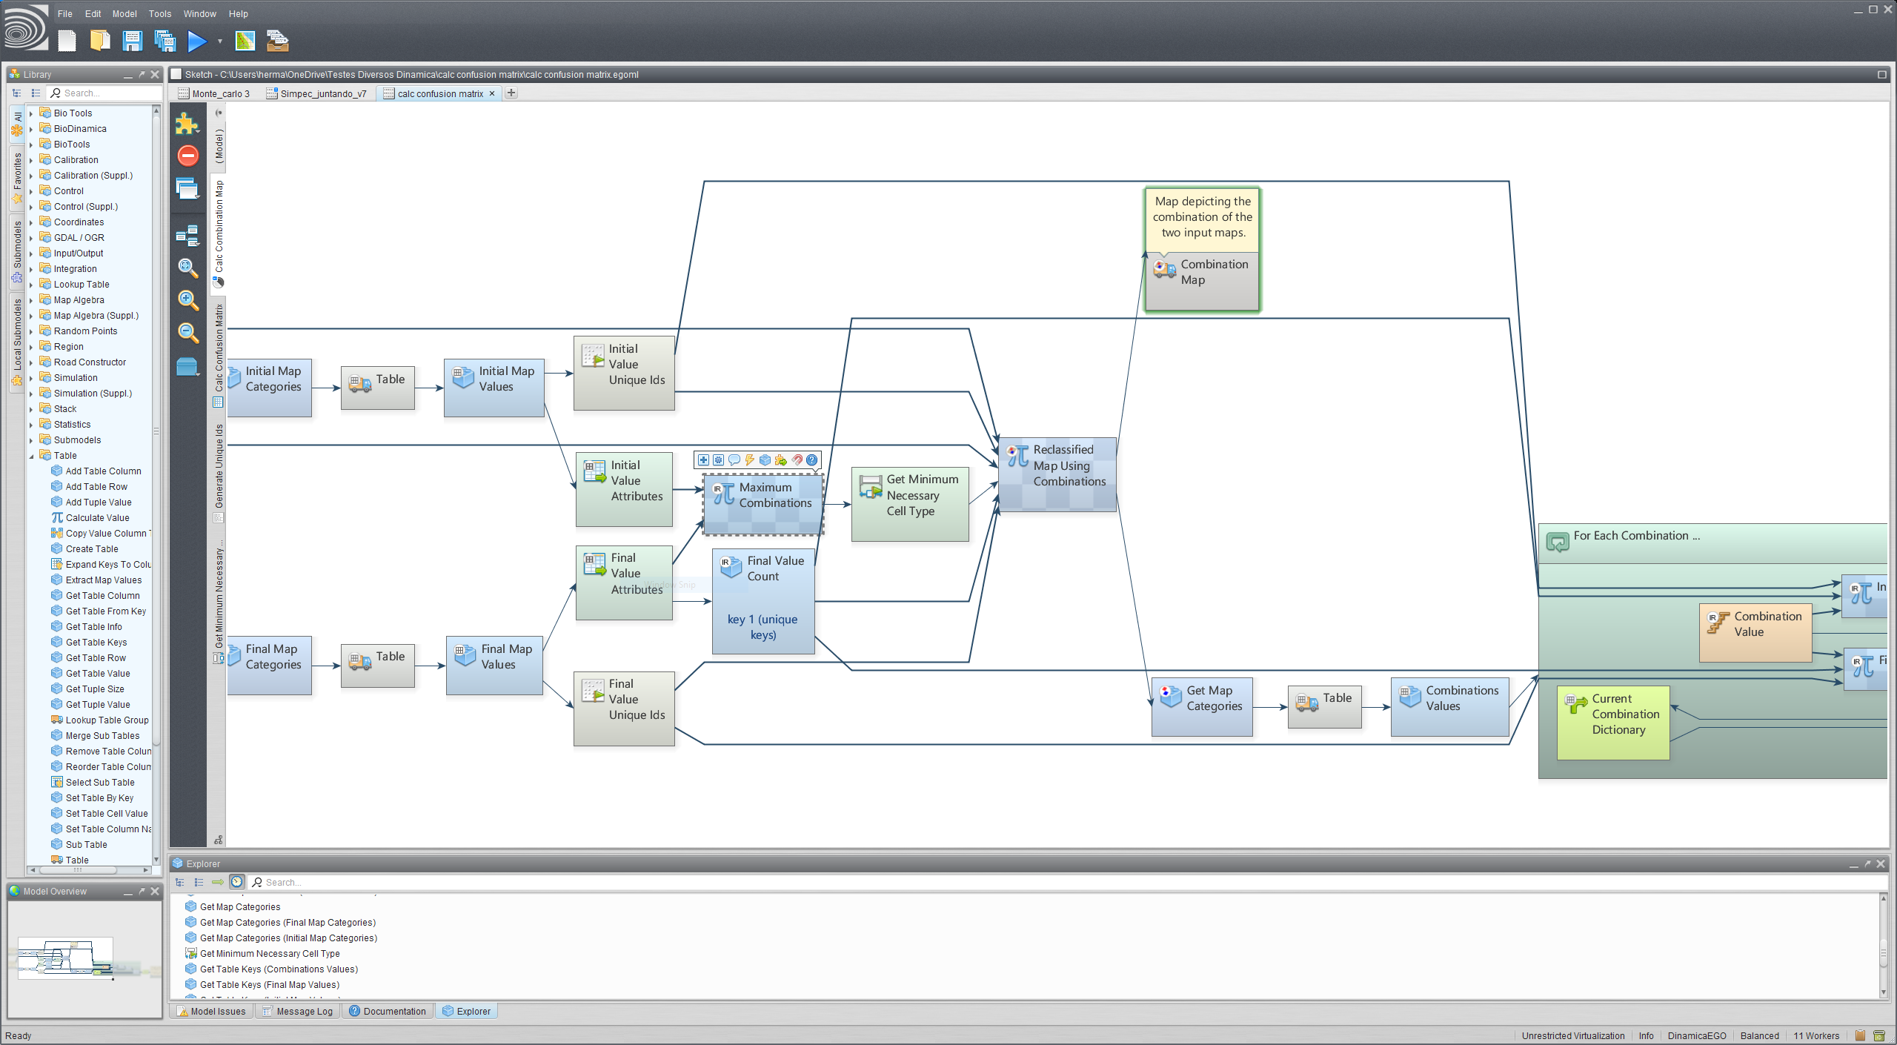

Documentation
- Dinamica EGO Website
- License Agreement
- Guidebook 2.0
- What Was New in version 3 | What Is New in version 4 | What Is New in version 5
- Screenshots
- Videos showing how to use Dinamica EGO 3, 4, and 5
- GUI Basics - Graphical Interface Elements
- Frequently Answered Questions (FAQ) / Troubleshooting
- Submodels
- Image Virtualization
- R Coupling
- Python Coupling
- How-To
- Useful Tips
- Functor List
- Utilities
- Plugins
- Submodel documentation
- Documentation Provided by the Community

Model Examples and datasets
 | https://csr.ufmg.br/imagery/guidebook_dinamica_5.rar

